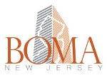
BOMA NJ HEART AWARD – Submission Criteria
- The Heart Award is a Local AWARD ONLY based on creative community involvement without a direct impact to the management budget. Open to ALL BOMA members only.

- Judging based on the following:

- What was the involvement of occupants and surrounding community?
- How did the community involvement help improve the quality of life and/or overcome obstacles?
- What was the amount of media coverage and positive profile for the community and the building liaisons?
- Amount of volunteering and fund raising rather than direct impact from budget.

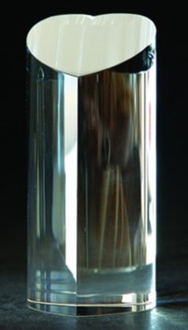
BOMA NJ
HEART AWARD
2016
GIVING TO OTHERS AND BENEFITING OUR COMMUNITY

You may nominate your building/management team or others by completing the following:
- How did the community involvement help improve the quality of life and/or overcome obstacles?
- What was the amount of media coverage and positive profile for the community and the building liaisons? Send copies of press releases or other media coverage received if applicable.
- How many volunteers were involved? # of hours?
- Would you do it again and if so, what would you do differently or keep it the same?
- Send your sample flyers/advertisement.
Heart Award Nominee (Building, Company, Individual):
Nominated by:
Contact Office Phone: Cell Phone:
250 - 500 Word Description:
Please note that judges may ask to review backup documentation. Attachments may be included in the original submission.
Mail or Email Submissions to Dolores Bocian, BAE - Boma-nj@optimum.net
BOMA New Jersey
PO Box 7250
North Arlington, NJ 07031
Deadline for submissions is February 25, 2016

