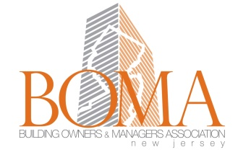

BOMA NJ HEART AWARD – Judging Criteria
- Local AWARD ONLY based on creative community involvement without a direct impact to the management budget. Open to ALL BOMA members only.

- Judging based on the following:

- What was the involvement of occupants and surrounding community?
- How did the community involvement help improve the quality of life and/or overcome obstacles?
- What was the amount of media coverage and positive profile for the community and the building liaisons?
- Amount of volunteering and fund raising rather than direct impact from budget.
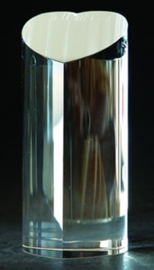
BOMA NJ
HEART AWARD
2017
GIVING TO OTHERS AND BENEFITING OUR COMMUNITY

Local AWARD ONLY based on creative community involvement without a direct impact to the management budget. Open to ALL BOMA members only.
You may nominate your building/management team or others by completing the following:
- How did the community involvement help improve the quality of life and/or overcome obstacles?
- What was the amount of media coverage and positive profile for the community and the building liaisons? Send copies of press releases or other media coverage received if applicable.
- How many volunteers were involved? # of hours?
- Would you do it again and if so, what would you do differently or keep it the same?
- Send your sample flyers/advertisement.
Heart Award Nominee (Building, Company, Individual):
Nominated by:
Contact Office Phone: Cell Phone:
250 - 500 Word Description:
Please note that judges may ask to review backup documentation. Attachments may be included in the original submission.

